
Mini Project Activity

ORANGE DATA MINING
Data Mining Fruitful and Fun
Open Source Machine Learning and Data Visualization

Project Members with Reg No:
Ritanshu Mahajan 25MCA10077
Shubham Kumar 25MCA10014
Shrawan Kumar 25MCA10043
Ashish Rajak 25MCA10048

Subject: Big Data Analysis
Course Code: MCA2004
Class ID: BL2025260500033

Guided By:
Dr. Ajeet Singh

Abstract
This report provides an overview of Orange, an open-source data-mining and machine-learning software platform, and its application in exploratory data analysis and model development. The purpose is to evaluate Orange as a practical tool for data mining by examining its architecture, key features, and typical workflow. The methods involve describing Orange’s visual-programming interface (Orange Canvas), its core components (data loading, preprocessing, visualization, and learning widgets), and the way these elements are assembled to build end-to-end data-mining pipelines.
Key findings indicate that Orange supports a wide range of tasks including data preprocessing, interactive visualization, classification, regression, clustering, and evaluation, all accessible through a drag-and-drop interface as well as Python scripting. The tool is particularly effective in educational settings and for rapid prototyping, thanks to its intuitive workflow design and integration with libraries such as scikit-learn. Orange also allows extensibility via add-ons for domains like bioinformatics, text mining, and network analysis.
The report concludes that Orange is a versatile, user-friendly, and open-source environment suitable for both beginners and advanced users interested in data mining and machine learning. Its strength lies in enabling interactive, visual exploration of data and quick comparison of models, though it may show limitations with very large datasets or highly optimized production-scale deployments.
Introduction
Data mining is the process of extracting meaningful patterns and knowledge from large datasets using techniques from statistics, machine learning, and database systems.
Among the many tools available today, Orange has emerged as a popular open-source environment for data visualization, machine learning, and data-mining education and research. This report provides an overview of the Orange data-mining tool, its architecture, key features, typical usage workflow, and its advantages and limitations for academic and practical applications.

Architecture and Core Components
Orange is built around a visual workflow model where the user connects widgets in a canvas to define a data-mining pipeline.
Each widget is a small computational unit that performs a specific task such as loading data, preprocessing, visualization, or model building.
Main component types
- Data-handling widgets:
  - File widget loads tabular data (e.g., CSV, Excel).
  - Data Table displays the loaded dataset in a spreadsheet-like view
- Preprocessing widgets:
  - Handle missing-value imputation, normalization, discretization, and feature selection.
- Visualization widgets:
  - Scatter plots, bar charts, histograms, box plots, heatmaps, and decision-tree viewers.
These help in exploratory data analysis (EDA) and model interpretation.
- Learning (modeling) widgets:
  - Classification, regression, clustering, and association-rule algorithms are implemented as separate widgets.
- Evaluation widgets:
  - Cross-validation, confusion matrices, ROC curves, and performance-metrics tables allow comparison of models.

The communication between widgets is data-flow based: output of one widget is connected to the input of another so that any change in the workflow propagates automatically.

Key Features and Capabilities
1. Visual programming interface
Orange’s drag-and-drop canvas lets users build data-mining workflows without writing code.
Non-programmers (students, domain experts, analysts) can quickly explore data and build predictive models, while still having access to formal machine-learning workflows.

2. Machine-learning algorithms
Orange integrates many standard algorithms from libraries such as scikit-learn through its widget interface. Commonly supported tasks include:
- Classification:
  - Decision Trees, Random Forest, Support Vector Machines (SVM), k-Nearest Neighbors (k-NN), Naive Bayes, Logistic Regression.
- Regression:
  - Linear regression, ridge regression, random forest regressor, etc.
- Clustering:
  - k-Means, hierarchical clustering, and other unsupervised methods.
- Association rules and pattern mining:
  - Frequent itemset mining and rule generation for market-basket-style analysis.

3. Interactive visualization
Visualizations in Orange are interactive: clicking on points in a scatter plot can highlight corresponding rows in the data table or in other linked widgets.
This interactivity is especially useful for:
- Outlier detection and anomaly analysis.
- Feature selection and dimensionality reduction.
- Explaining model behavior and decision boundaries.

4. Extensibility and add-ons
Orange supports add-on packages that extend its functionality into specialized domains. Examples include:
- Bioinformatics and genomics (gene-expression analysis, enrichment, etc.).
- Text mining and NLP (preprocessing text, topic modeling, sentiment-analysis-style workflows).
- Network analysis and time-series analysis.

Advanced users can also embed Python scripts inside workflows for custom steps not covered by existing widgets.
Typical workflow in Orange
A typical Orange data-mining workflow follows these steps:
- Load data
  - Use the File widget to import a dataset (e.g., CSV, ARFF, or Excel).
  - Connect it to a Data Table widget to inspect the data.
- Preprocess data
  - Apply widgets for missing-value handling, normalization, feature selection, or discretization.
  - Optionally split data into training and testing sets.
- Explore and visualize
  - Use scatter plots, box plots, or histograms to check distributions, correlations, and outliers.
- Build models
  - Drag a learning widget (e.g., Decision Tree, SVM) onto the canvas and connect it to the preprocessed data.
- Evaluate models
  - Connect an evaluation widget (e.g., Test & Score) to one or more learners and inspect accuracy, AUC, confusion matrices, etc.
- Interpret and export
  - Use visualization and explanation widgets (e.g., decision-tree viewer, ROC curves) to interpret results.
  - Export results (model specifications, figures, or predictions) for reporting.

This style of workflow makes it easy to experiment with multiple models and preprocessing steps rapidly, which is ideal for teaching and exploratory projects.

Educational and Practical Applications
Orange is widely used in machine-learning and data-mining courses because it lowers the barrier to entry for students who are new to programming or statistics.
Instructors can design exercises where students compare different algorithms on the same dataset, visually inspect overfitting, and perform cross-validation without writing any code.
From an applied standpoint, Orange is useful for:
- Exploratory data analysis in small-scale research or industry pilot projects.
- Prototyping machine-learning pipelines before implementing them in production code.
- Domain-specific analysis (biology, healthcare, social-network analysis) via add-ons.
Advantages of Orange
- No-code or low-code learning curve: Students can focus on concepts (classification, clustering, evaluation) instead of syntax.
- Immediate visual feedback: Dynamic plots and linked widgets help users understand how changes propagate through the workflow.
- Open-source and free: Orange is freely available under an open-source license, which is important for academic and budget-constrained projects.
- Extensible: Python scripting and add-ons let users move beyond the GUI when needed.
Limitations and Drawbacks
- Scalability: Orange is best suited for medium-sized datasets; very large datasets may slow down or not fit well in the GUI workflow.
- Performance optimization: For high-performance or production-scale machine-learning pipelines, one typically moves to direct Python libraries (e.g., scikit-learn, PyTorch) instead of metaphases built on Orange.
- Learning complexity: While the GUI is approachable, understanding good modeling practices (cross-validation, hyperparameter tuning, bias-variance trade-off) still requires students to grasp underlying theory.

Conclusion
Orange is a powerful, open-source data-mining and machine-learning environment that greatly simplifies the process of exploratory data analysis, model building, and evaluation. Its visual-programming interface (Orange Canvas) allows users to construct workflows by dragging and dropping widgets for data loading, preprocessing, visualization, and modeling, making it accessible even to those with limited programming experience.
The tool supports a wide range of tasks such as classification, regression, clustering, and association-rule mining, while integrating well-known algorithms from libraries like scikit-learn. Interactive visualizations and model-evaluation widgets help users compare multiple models quickly and understand patterns in their data.
However, Orange is best suited for medium-sized datasets and educational or prototyping use. Overall, Orange is a highly effective platform for learning data-mining concepts, performing rapid experimentation, and building understandable, visual workflows for real-world datasets.

Project Output:
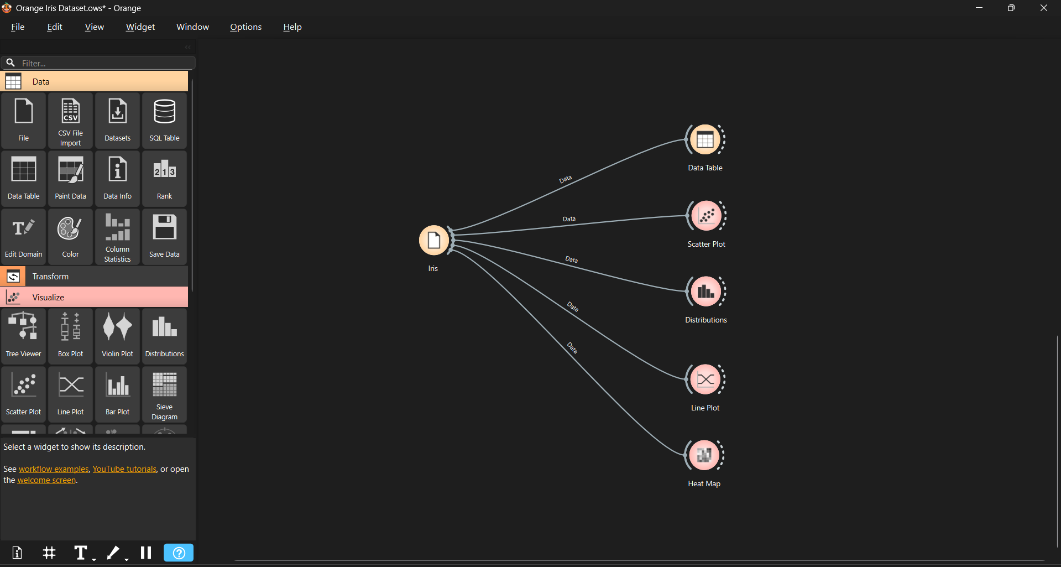
Iris Dataset: Data Table
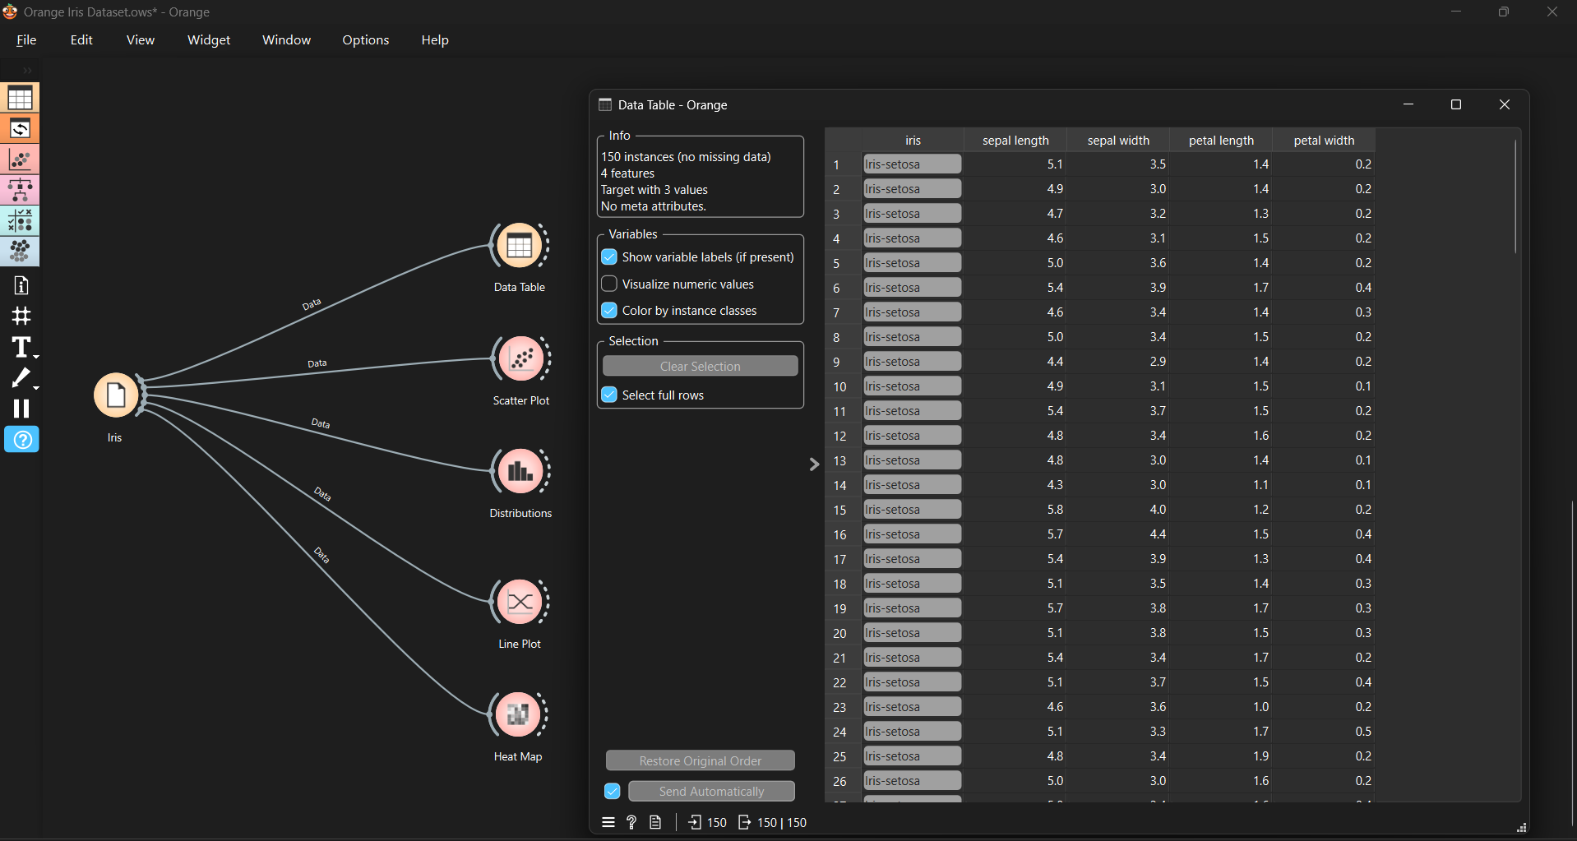

Scatter Plot:
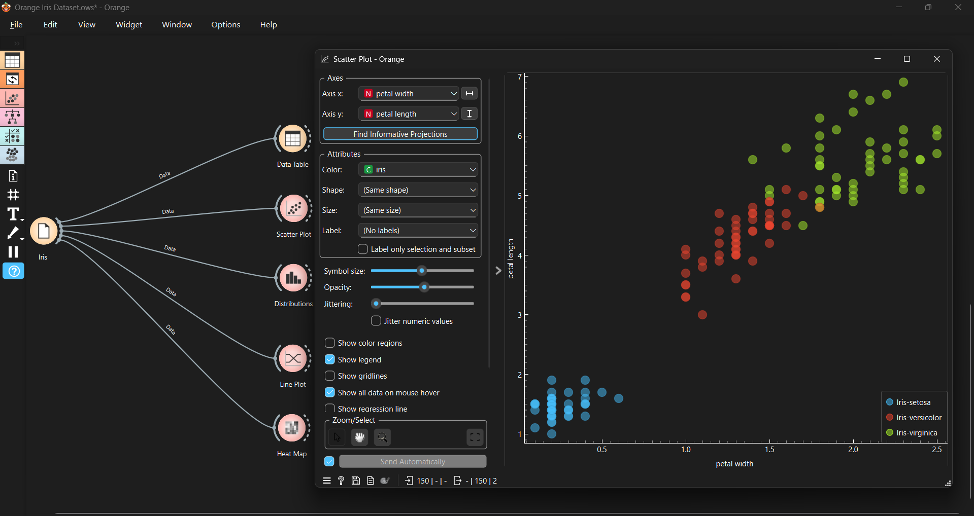
Live Plot:
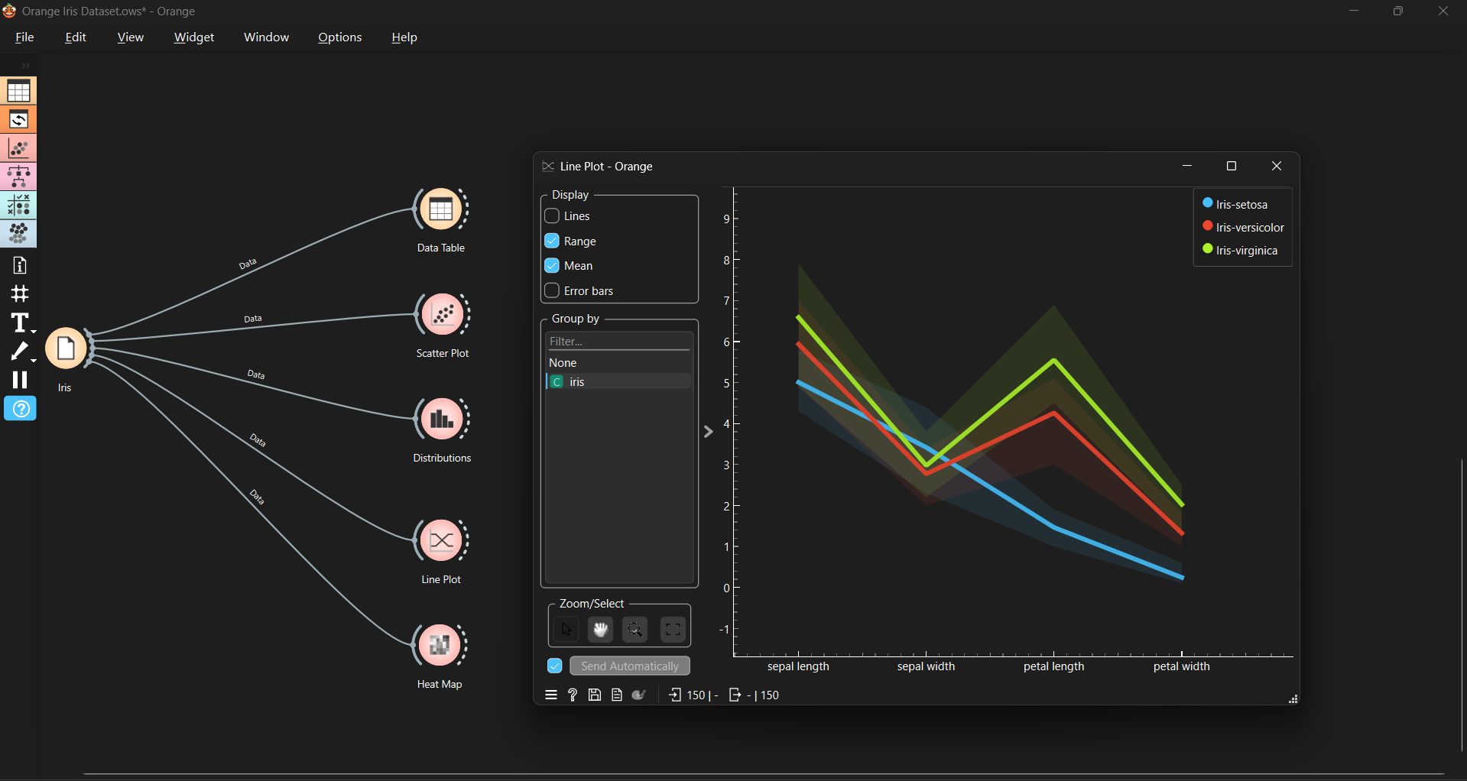
Distributions:
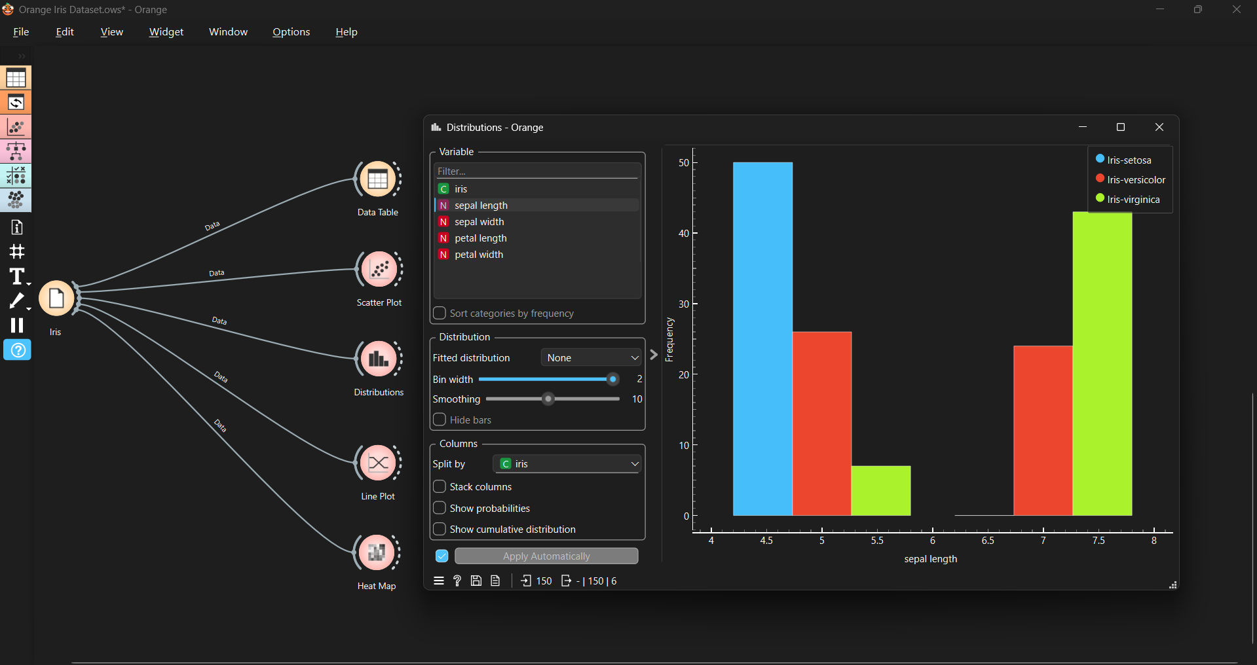

Links And References:
https://orangedatamining.com/
https://www.kaggle.com/datasets/uciml/iris

